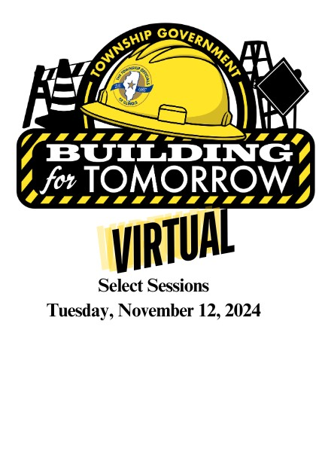
117th Annual Educational Conference
Virtual Experience - Select Sessions
Tuesday, November 12, 2024
Registration Deadline November 8, 2024
We know nothing can beat the in-person TOI Annual Conference experience where you can see old friends, make new connections, and have those valuable in-person conversations that take place during the breaks, over breakfast or after-hours. But for those who are unable to attend the conference in-person, we are excited to announce a limited virtual experience!
Gain access to key sessions, streamed LIVE on Tuesday, November 12 from 9am – 5pm. Receive a link after the event with a virtual attendee survey AND links to the recorded sessions.
- General Session from 9am – 11:30am.
- Session 1 from 12:30 – 1pm: TOI Legislative Update with TOI lobbyist, Taylor Anderson.
- Session 2 from 1:15 – 2:15pm: Ask an Attorney (Panel).
- Session 3 from 2:45 – 3:45pm: Secrets of Smooth Transitions Between Administrations with Keri-Lyn Krafthefer, Ancel Glink.
- Session 3 from 4-5pm: 2025 Township Elections with Ross Secler.
- A $99 rate for TOI Members; $250 for Non-Members.

Requirements to participate:
- You will need an internet connection.
- You will need an email address to verify registration and receive log in credentials. One unique email account per registrant.
- You will need a web browser (Chrome is Recommended).
County Township Address City State Zip
Names & Email of those who will attend (please print clearly):
Supervisor: Township Clerk: Highway Comm.: Assessor: Trustee: Trustee: Trustee: Trustee: Collector: Other/title:
*Please make checks payable to the Township Officials of Illinois; mail to 3217 Northfield Drive., Springfield, IL 62702. Forms may also be emailed to teresa@toi.org or faxed to 217.744.7419.
Name, as it appears on card: Credit Card Number_____________________________________ Exp:

